EXCLUSIVE: 'Fake facts, deceptive editing and omission of key evidence.' Making a Murderer prosecutor Ken Kratz breaks his silence about never-before-revealed proof that Steven Avery IS guilty and accuses the producers of duping viewers
- Ken Kratz makes his case on how Making a Murderer duped the public in his new book, Avery: The Case Against Steven Avery
- Using evidence never before revealed, Kratz shows why he believes Avery is indeed guilty of the violent 2005 murder of Teresa Halbach
- Kratz, who prosecuted Steven Avery and Brendan Dassey for the murder in 2007, says he received over 4,000 death threats in the aftermath of the series
- He lost his law firm and even had exploding packages sent to his office
- He says the show's producers fabricated facts, omitted key evidence and used deceptive 'splicing' editing practices to make Avery seem innocent
- 'The filmmakers have distorted the case - this isn't what the jury got to see or hear when they decided Mr. Avery was guilty,' Kratz tells DailyMail.com
By Emma Foster For Dailymail.com
The producers of hit documentary Making a Murderer duped millions of viewers into wrongly believing convicted killer Steven Avery is innocent by fabricating facts, omitting key evidence and using deceptive editing practices to misrepresent even courtroom testimony, according to a bombshell new book.
Using evidence never before revealed, maligned chief prosecutor Ken Kratz attempts to 'set the record straight' in the controversial case by proving Avery is guilty of the violent 2005 murder of Teresa Halbach.
He also shows how the filmmakers ruined the lives of two exemplary police officers Lt. James Lenk and Sgt. Andy Colborn by accusing them of framing the 54-year-old without any shred of evidence.
The explosive book, titled Avery:The Case Against Steven Avery and What 'Making a Murderer' Gets Wrong, reveals how the Emmy-winning documentary left Kratz's life in tatters; including how he received over 4,000 death threats in the aftermath of the series, lost his law firm, his livelihood and even had exploding packages sent to his office.
Kratz, 56, who was painted as the central villain of the groundbreaking documentary, tells DailyMail.com it was time to 'stand up' for the conviction, for the wrongly-accused police officers and most importantly for the victim Teresa, a much-loved photographer who was murdered and mutilated by Avery on his family's salvage yard in Manitowoc County, Wisconsin.
In an exclusive interview with DailyMail.com, Kratz also called for the filmmakers to be held to account and for the film industry to set standards for documentary editing to prevent similar misrepresentation taking place again.
'Making A Murderer is a very good piece of entertainment but it's not really what happened - it's simply not how the case happened in real life,' Kratz said.
'The filmmakers have distorted and misrepresented the case - this isn't what the jury got to see or hear when they decided Mr. Avery was guilty.
'Because law enforcement and the officers involved had chosen to stay quiet I decided somebody had to step forward and stand up for the victim of the case Teresa Halbach and also for the conviction itself.
'The Making A Murderer folks and their supporters claim this is an example of how the system in the U.S. just isn't fair to poor people and how the state had targeted Mr. Avery and planted evidence, but this just isn't true. The process in this case worked very well.
'Not only did Mr. Avery have very, very good representation but all the issues filmmakers are raising now and presented in Making A Murderer were already presented to the jury.
'The difference is that in the trial I got a chance to present evidence to counter act and rebut their allegations - whereas in the series I did not.
'When the filmmakers came out with Making A Murderer it was so clearly not only biased but distorted in the sense that the public worldwide were being told certain facts existed or there wasn't evidence to convict him and evidence they did have was somehow shady or sketchy - that just simply wasn't true.
'I believe the filmmakers knew they were being dishonest when they presented the case in the manner they did.
'They knew they had a narrative to present and they picked and chose certain clips, they shuffled things around to make it look sketchy and they omitted a lot of the relevant evidence.
'There wasn't really an effort by mainstream media to call them out on their deceptive editing practices.
'A book needed to be written, the record needed to be set straight and that's what I intended to do with this book.'
Kratz's biggest complaint about the Netflix series, which first aired in December 2015, was the filmmakers' use of an editing technique called splicing, which is taking an answer given in one place and using it to answer another question - or even a question never asked in real life.
In one example, Sgt Colborn made a call to dispatch to confirm the license plate of Teresa's vehicle, so he knew what he was searching for. This is standard practice.
The defence argued that in fact Colborn had found the vehicle and was ringing the plate in as he was stood behind it to confirm he had the right car, which would suggest he found the car days before it was officially found by a member of the public, therefore giving him time to plant evidence in it.
In court he was asked: 'Can you understand why someone listening might think you were calling in a license plate looking at the back of a 1999 Toyota?'
And on the Making A Murderer he answers 'Yes.'
However in court he never answered the question as the judge didn't let him.
Instead filmmakers insert Colborn's 'Yes' from another question: 'This call sounded like hundreds of other license plate or registration checks you have done through dispatch before?'
So Kratz argues that this editing misrepresented the court testimony and makes Colborn look suspicious.
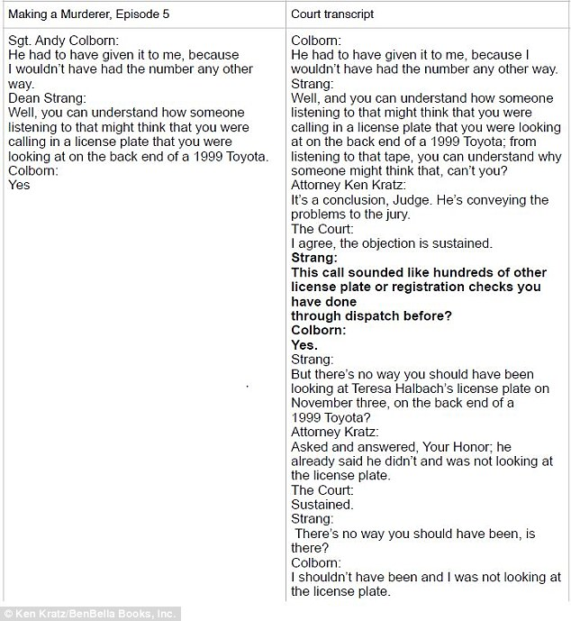

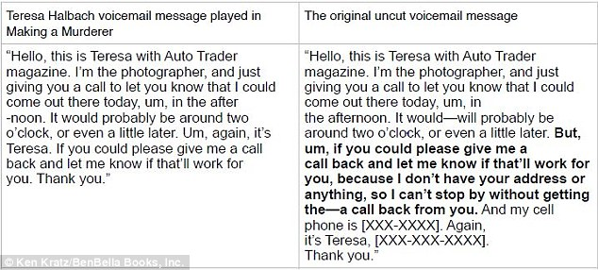
Kratz also points to a six-second segment of Teresa's voicemail on the day of her murder where she says she doesn't know where she is going or who she is meeting, which is edited out of the documentary, as shown above
Kratz said: 'The splicing is even more egregious than fabrication in my opinion. You may get facts wrong or fabricate certain things but what filmmakers never do is take an answer given to one question and make it look like it answered another.
'The filmmakers did a lot of things like omit things, shuffle things around or only tell you things that support their narrative but when a filmmaker is willing to show trial testimony and tell viewers: 'This is what happened, this is what the jury got to see' and then afterwards you find out it's not - it's unforgivable.
'They edited trial testimony to make witnesses look dishonest or unprofessional - and it served to cast certain people - such as Sgt. Colborn - as villains.'
Kratz also points out several examples of fabrication - where filmmakers knowingly presented something as true when it was not.
One of the central theories of the defense - and of the Making A Murderer series - is that a hole found in a vial of Avery's blood from his false rape conviction proved that it had been tampered with and that blood could have been taken from it to plant in Teresa's car.
However Kratz argues this theory was disproved early on - with a nurse providing written testimony that she made the hole in the vial when she originally drew the blood from Avery.
'The filmmakers, Kratz claims, knew at the time of the trial that this theory wasn't true because the defense team abandoned it - it turned out a nurse put that hole in the vial when she took the blood from Avery and she gave a sworn statement saying that.
'But you wouldn't have known that if you watch Making A Murderer and you hear Avery's lawyer Jerry Buting says, 'This is a red letter day for the defense now we have this hole.'
'Well they don't tell you over the next four or five episodes that is nonsense and it has been proven so.
'They are fooling people and shame on them.
'They also suggest that Lt. Lenk sent the vial of blood to the crime lab for testing and the filmmakers show the transmittal form as proof it was used to transmit the blood.
'Well we come to find out that the vial of blood was never transmitted at all and Lt. Lenk did not know of the existence, never handled it or sent it to the crime lab in 2002.
'But despite this, the filmmakers never reveal this - it remains one of the centerpieces of their accusations.'
The filmmakers are also heavily criticized for omitting several key pieces of evidence - including the fact that a bullet containing Teresa's DNA was proven to have been fired from Avery's own gun and that all of Teresa's electronic devices were found burned in Avery's burn barrel - and two separate witnesses said they saw him burning something on the day of Teresa's murder.
'There were two bullets that were found - one was flattened and damaged to the point you couldn't get any ballistics testing on it, and then there was an intact bullet with the DNA - the bullet in question,' Kratz explains.
'But what they show in Making a Murderer is the officer testifying about finding the flattened bullet which doesn't have any ability to provide any forensic evidence and they use that bullet as if they were talking about the other one with the DNA.
'So they take the testimony on the damaged bullet and insert that into the discussion about the other bullet to distort reality and make the police look incompetent.'
Kratz also points to a crucial six-second segment of Teresa's voicemail on the day of her murder where she says she doesn't know where she is going or who she is meeting, which is edited out of the documentary.
This, he claims proves that Avery lured Teresa to the yard, and to cut it out distorts the entire message.
Kratz now wants filmmakers to explain their decision-making and is calling on the documentary industry to take action.
'I have asked the filmmakers for answers,' he said. 'I've asked why they spliced answers, shuffled things around and omitted key evidence.
'Why did they cut six seconds out of Teresa Halbach's voicemail for example?
'This is when you realize how insidious this was and how these decisions accumulate together to present this really distorted view.
'Yet the documentary goes unchecked and unchallenged to the point where these filmmakers receive four of the biggest awards a documentary maker can receive - an Emmy - one of which was for editing.
'Well how can the industry give them an award for using these deceptive editing practices - where they edit to the point that they are creating a narrative not just reporting it anymore?
'I hope people are not only going to be angry, but that the film industry does something - for example create a set of standards - to make sure this doesn't happen again.
'At the very least I don't think these filmmakers can truly say any longer that they didn't know what they were doing - or that they weren't editing it for the sole purpose of suggesting Mr. Avery is innocent. That is obviously what they were doing.
'If I was able to spoon feed an audience for 10 hours facts that I could pick and choose, edit or even create from other clips I could get an audience to believe whatever I wanted them to believe.
'I think everyone who watched that show has an entitlement to be angry that this happened, that they were fooled, that they were convinced to act and sign petitions for Avery's release when it turns out he's exactly where he belongs.'
For Kratz, the hidden tragedy of what became a hugely successful documentary is the devastating impact the series had on the lives of Lt. Lenk, Sgt. Colborn and himself.
All three received thousands of death threats directed to them and their families and were accosted in the street and at their homes.
Exploding glitter bomb packages were sent to Kratz's office and that of the Manitowoc County Sheriff's Department.
Chillingly, Kratz even received messages from men who said they wanted to rape and kill his daughter - fortunately he does not have a daughter.
Lt. Lenk suffered a heart attack soon after Making A Murderer came out while Sgt. Colborn was so afraid he bought his blind wife a gun so she could protect herself from would-be attackers.
Kratz himself became embroiled in a sexting scandal shortly after the Avery case and began abusing prescription drugs.
This cemented his guilt in the framing of Avery in many people's minds - and he does not shy away from the subject in the new book.
He lost his law firm in the aftermath of the documentary and now no longer practices.
'I received many death threats, hateful emails and calls to my practice in northern Wisconsin, and because of the outrage directed towards me we had people calling our office every minute tying up our phone lines so we couldn't deal with legitimate law firm calls,' he said.
'We'd get hundreds of voicemails and emails and our existing clients felt intimidated and they didn't want me as an attorney because of all the attention and publicity so they drove my law firm into the dirt - I was not able to recover.
'The filmmakers' decision to cast Colborn and Lenk as the villains and as crooked and bent had such a dramatic impact on the lives of these two men - it is the human cost of these decisions.
'Andy Colborn's wife is legally blind and was so scared because of the death threats and people coming to their house and accosting them that he had to provide his wife with a gun even though she is blind.
'Lt. Lenk's wife had knee surgery in Arizona shortly after the documentary came out and as she was being wheeled out of the hospital, the nurses ask her where she is from and then say, 'isn't that where those two crooked cops are from?' So even when she is recovering from surgery she has to hear that her husband who has done nothing but serve his community well, is crooked.
'And when all these supporters of Steven Avery say how terrible these cops are, when they learn what actually happened and that they were simply fooled and the filmmakers cast these two really good police officers as villains I hope there's going to be an apology, not just from the filmmakers but from all these thousands of people who have sent death threats.
'They deserve to have their reputations returned to them.
'In 11 years no one has been able to come up with any evidence that suggests either one of these cops was involved in Avery's prior case, or did anything unethical or dishonest and not one shred of evidence has been found because these are two of the most honest cops I ever met.
'You might think 'Oh this is just entertainment' or 'So what it's just a TV series' but very real people were impacted in a very real way by the filmmakers' decision to be deceptive and that's something they should be held accountable for.
And for those still skeptical of Kratz - he has one last message: 'I've got the truth on my side. I'm able to back up all my comments with real evidence and documents.
'No one has to believe a single word I say - this is all documented, this all comes from materials I've already shared or have the ability to share if anybody wishes to look at them.'
Kratz will be appearing on NBC Dateline on February 17 along with detective Tom Fassbender.
DailyMail.com attempted to reach filmmakers Moira Demos and Laura Ricciardi for comment. Netflix has no comment.
Read more: http://www.dailymail.co.uk/news/article-4219732/Making-Murderer-prosecutor-says-Steven-Avery-guilty.html#ixzz4YsAZzKYG
Follow us: @MailOnline on Twitter | DailyMail on Facebook

